

**Assignment on**

Electronic Device and Circuits

Topic: p-type Semiconductor

Course Code: CSE224

**Submitted to:**

Md. Sayedul Arefin  
Dept of CSE

**Submitted by:**

**Date: 9.10.2016**

* **P-type Semiconductor**

To explain p-type semiconductor, we have to know about semiconductor.

**Semiconductor:** A semiconductor is a substance, usually a solid chemical element or compound that can conduct electricity under some conditions but not others, making it a good medium for the control of electrical current.  
Shortly, a semiconductor is a substance, which has resistivity in-between conductors and insulators.

Depending upon the type of impurity added, semiconductor is classified into two types.

* **p-type semiconductor**
* **n-type semiconductor**

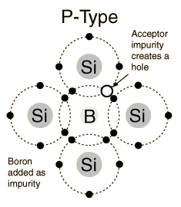**Definition of p-type semiconductor:** The addition of trivalent impurities such as boron, indium, aluminum or gallium to a pure semiconductor is called p-type semiconductor. It creates deficiencies of valence electrons, called "holes". 

A p- type semiconductor is formed when a small amount of trivalent impurity is added to pure Germanium or silicon atom crystal. The addition of trivalent impurity produces a large no. of holes to the host crystals. To explain the formation of P - type semiconductor, let us introduce a trivalent impurity into the lattice of a pure silicon crystal. The trivalent atom has 3 valance electrons and form covalent bonds with neighboring atoms. The 4th bond is incomplete. The trivalent atom then attracts an electron from an adjacent atom there by completing the 4th bond and forming a hole in the adjacent atom. Since a trivalent impurity atom provides 1 hole, an enormous increase occurs in the number of holes. The impure crystals so obtained is

[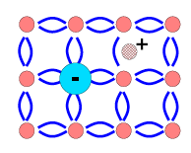](http://1.bp.blogspot.com/_ZxVxQf3ADns/TO-KqBInYrI/AAAAAAAAAB0/DUhSEtw89Jg/s1600/2.png)

Called p-type semiconductor where P represents the positive charge on hole. Thus, the majority carrier in a p-type semiconductor is holes. Free electrons are also present in the p-type semiconductor.

**Energy Band Description of p-type Semiconductor:** The addition of trivalent impurity has produced a large number of holes. It contributes hole level low in the semiconductor band gap so that electrons can be easily excited from the valance band into this level, leaving holes in the valance band. This shifts the effective to a point about halfway between the acceptor fermi levels and the valance band.

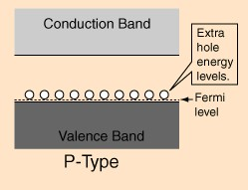

The Fermi level is the maximum energy, which can be occupied by an electron at absolute zero. Electrons can be elevated from the valance band to the holes in the band gap with the energy provided by an applied voltage. Since electrons can be exchange between the holes, the holes are said to be mobile. The holes are said to the “majority carriers” for current flow in a p-type semiconductor.

**P-type Conductivity:** The conduction of current in p-type semiconductor predominately by holes i.e. positive charges is called p-type or hole type conductivity.

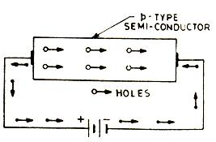

Holes are positively charged in p-type semiconductor. Wholes are shifted from one co-valent bond to another co-valent bond during the time of p.d is applied. Positively charged holes are directed towards the negative terminal, which makes hole current.